**All about Crepemyrtles and Their Pruning**

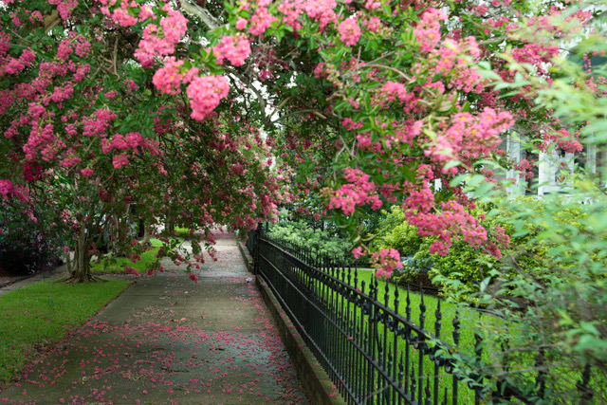

[This Photo](https://mississippitoday.org/2019/06/20/a-blooming-spectacle-new-crepe-myrtle-festival-invites-the-world-to-visit-natchez/) by Unknown Author is licensed under [CC BY-ND](https://creativecommons.org/licenses/by-nd/3.0/)

Dustin Blakey

County Extension Agent - Agriculture

Here are some facts about crepemyrtles to dispel some common myths regarding their care and selection.

**Myth:** Crepemyrtles need to be cut back every year to flower their best.

**Fact:** Nothing could be farther from the truth. Crepemyrtles, like most plants, should not be topped. It ruins the form of a naturally graceful plant.

**Myth:** Crepemyrtles need pruning in fall.

**Fact:** Like the vast majority of plants, you should avoid pruning in the fall. It can induce winter injury and leave an unsealed wound exposed for the maximum time.

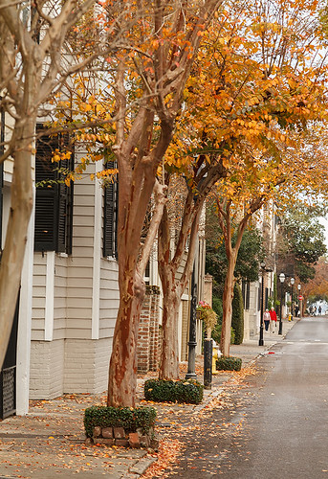

[This Photo](https://www.flickr.com/photos/doddsjzi/16038492325/) by Unknown Author is licensed under [CC BY-NC-ND](https://creativecommons.org/licenses/by-nc-nd/3.0/)

**How to prune a crepemyrtle:**

1. This plant sends up suckers. Select an odd number: 5, 7, or 9 trunks look best. Remove all others at the ground. Pick ones that are not rubbing together and that form a nice base.
2. Remove any branches that are rubbing against each other.
3. If your variety gets too tall, remove 1/5 of the trunks to the ground. Select an equal number of suckers to replace them and remove the rest. Do this each year, and in 5 years, you will have a smaller specimen.
4. Never arbitrarily cut back the limbs to a set height. It is ugly and physiologically harms the plant. This is one deciduous plant that looks good in the winter. Do you really want to look at bare knuckles in your yard all winter?
5. You don’t need to remove the little berries unless you really don’t like them. If you must remove them, just snip them off – nothing too severe.
6. Remember that plants don’t always behave well. Just do your best and don’t be a control freak.

**How to save a badly topped or badly pruned crepemyrtle:**

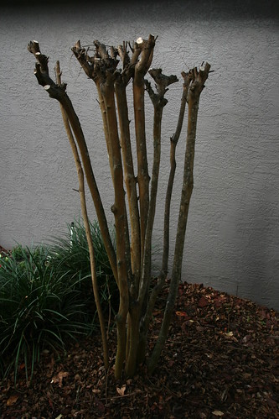

[This Photo](https://www.flickr.com/photos/67495976@N00/3141731524/) by Unknown Author is licensed under [CC BY-NC-ND](https://creativecommons.org/licenses/by-nc-nd/3.0/)

1. If you are currently looking at “bare knuckles” from a plant that has been cut back to its main trunks, select one or two of the newest outside branches on each trunk and remove the rest. You’re now on the road to recovery.
2. If it has been hacked indiscriminately, you have 3 options:
   1. Try to correct the growth by thinning out crossing branches and opening up the canopy. Try to select branches heading outward.
   2. Cut the whole thing to the ground and start over. This isn’t great for the plant, but you won’t kill it either. Select 5, 7, or 9 trunks, depending on the vigor, and remove the rest.
   3. Leave it alone. This will leave it looking a little wild and messy. Thin out the canopy a bit in the winter.

**Myth:** They get so big unless I top them!

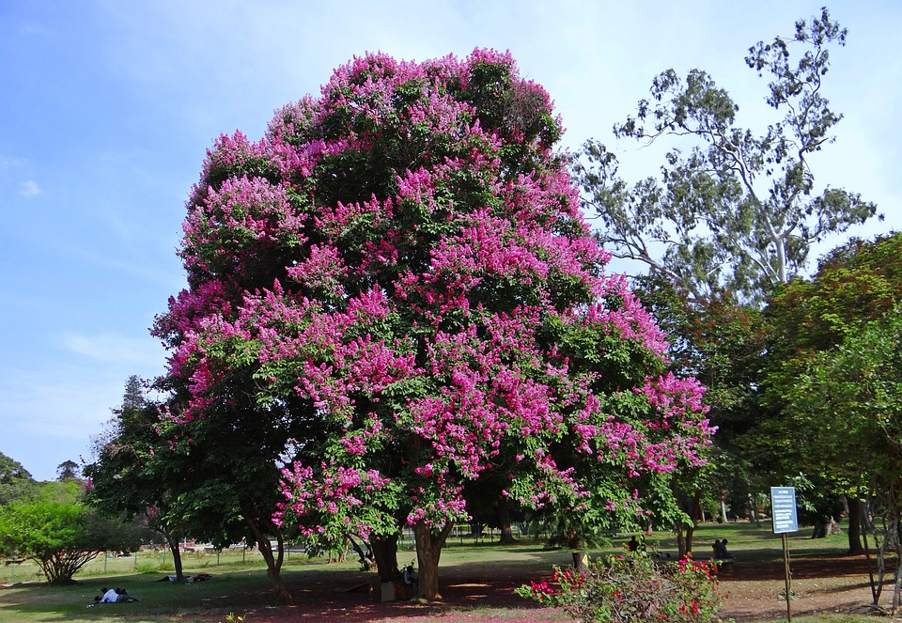

**Fact:** Many can get huge, but if you select the right variety, you won’t have to butcher them annually. In our area, many of the varieties that say “dwarf” are in fact medium height, which means that they will get to be about 16 feet tall! Read the label carefully or ask your nurseryman. True dwarf varieties stay under 6 feet tall. If you really want a small one, ask for “Chickasaw,” which grows only 2 feet tall.

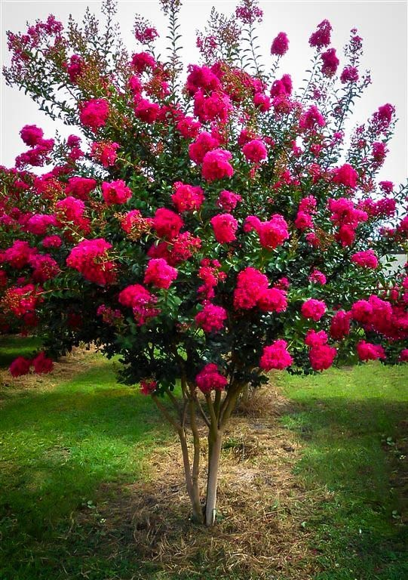

[This Photo](http://gardening.stackexchange.com/questions/28612/how-to-grow-crepe-myrtle-to-look-like-umbrella) by Unknown Author is licensed under [CC BY-SA](https://creativecommons.org/licenses/by-sa/3.0/)

**Here are some other interesting facts about our favorite abused landscape plant:**

* In the wild, crepemyrtles are TREES! Therefore picking the right variety is important in shaping your landscape. [UACES has an extensive database of crepemyrtle varieties and their sizes.](http://www.aragriculture.org/horticulture/ornamentals/plant_material/crapemyrtle/default.asp)  Also look at the tag when you buy a crepemyrtle. The tag will tell you how tall they get. Believe them. Varieties range from 2 feet to 45 feet. Life is easier when you get the right kind.
* You can keep your crepemyrtles flowering until frost by clipping off the flower clusters (deadheading) as soon as they turn brown. This works because crepemyrtles flower on current year’s wood.
* The term coined for the practice of topping crepemyrtles is “Crepe Murder,” but I’ve also heard “Crepe Rape.”
* Crepemyrtles need full sun. If you plant them in the shade, expect to get a lot of powdery mildew on them. Spraying for control doesn’t make much sense and is costly. Try to improve light levels and airflow.
* On rare occasions (it’s been many years since the last time) crepemyrtles can get severe winter damage. Damage varies by the crepemyrtle’s variety, but it only kills the top portion of the plant. The very old pink variety found at older Fort Smith homes seems more susceptible to this than others.
* The variety “Dynamite” was an [Arkansas Select](http://www.arhomeandgarden.org/landscape/ArkansasSelect/default.asp) plant and is highly recommended for a large specimen or screen.

I chose to add a photo to “All about Cr(a)pe Myrtles”. I didn’t realize it was misspelled until ¾ of the way through! Refraining from editing the copywriting, which would have fit nicer on some of the pages with heavy text, I tried to format them similarly, but still allow for enough whitespace. Using a Canva template as a starting off point, I found images of crape myrtles and let that be the basis for the color palette. The title is the largest size font, and I used the Fibonacci scale to size the remaining headings. Images are from Wikimedia. Separate